**MODEL BUILDING**

**PREDICTIONS**

|  |  |
| --- | --- |
| Team ID | PNT2022TMID14000 |
| Project Name | Project-Emerging methods for early detection of forest fires |

**PREDICTIONS:**

The last and final step is to make use of our saved model to do predictions. For that we have a class in keras called load_model. Load_model is used to load our saved model h5 file (alert.h5).

**IMPORT LIBRARIES:**

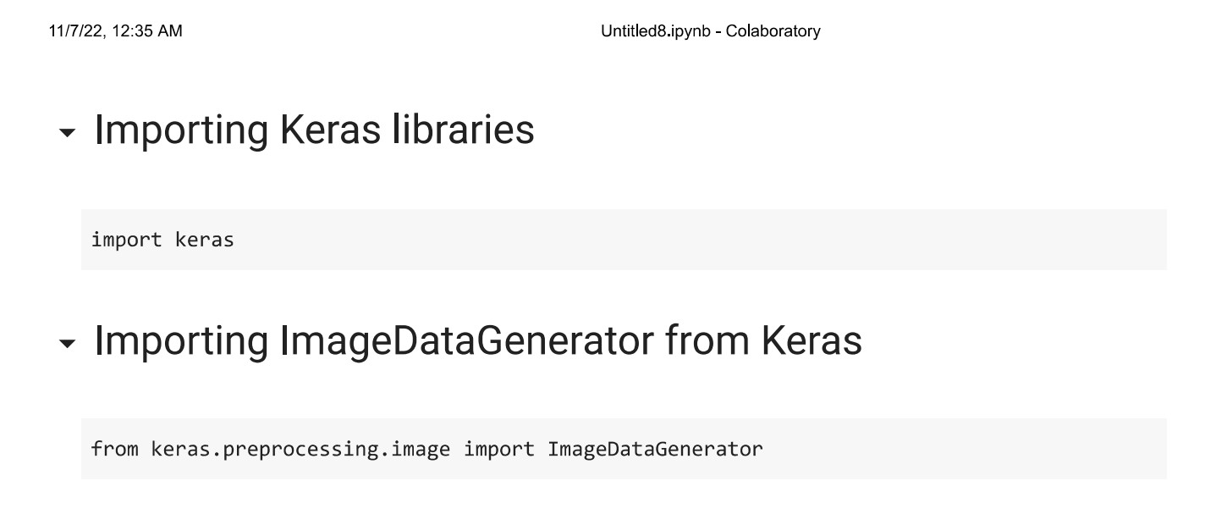

**IMPORT ImageDataGenerator FROM KERAS:**

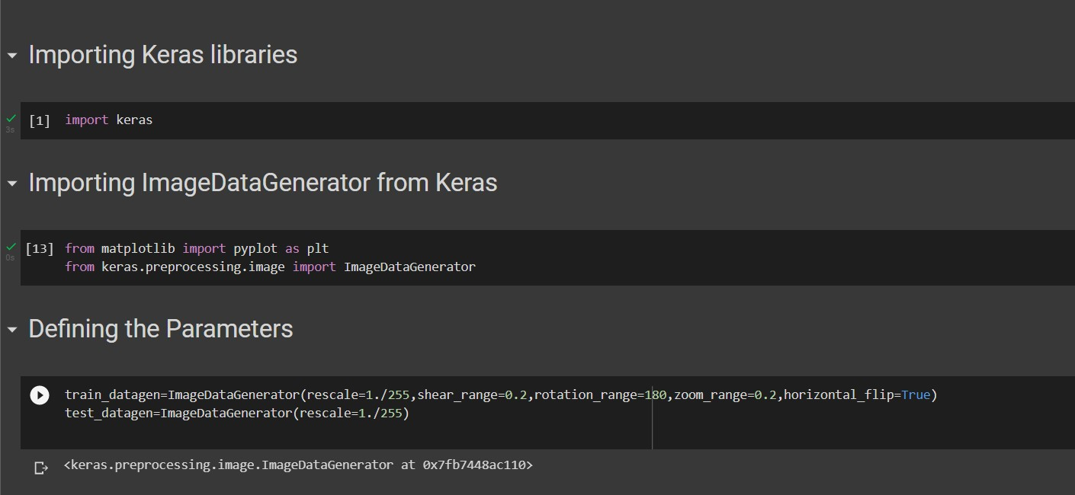

**APPLYING ImageDataGenerator to train dataset:**

ply**flow_from_directory ( )**methodfor Train folder.

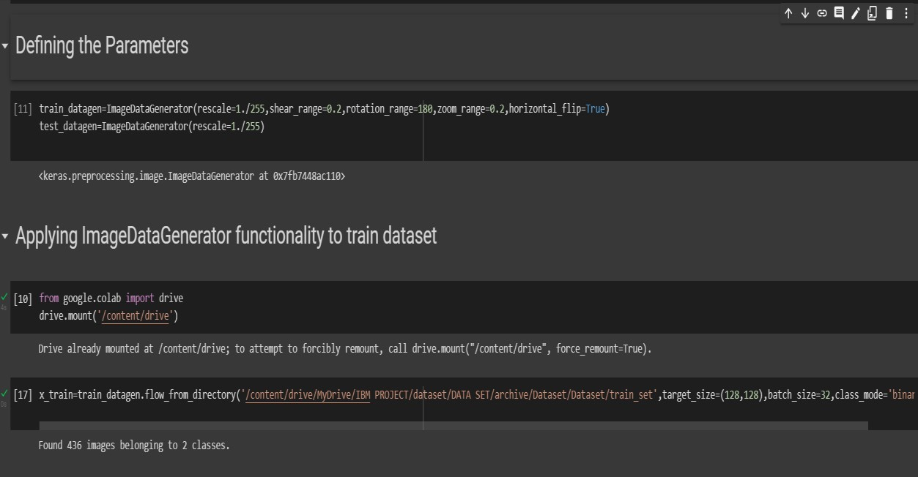

**APPLYING ImageDataGenerator to test dataset:**

Applying the **flow_from_directory ( )** methodfortest folder.

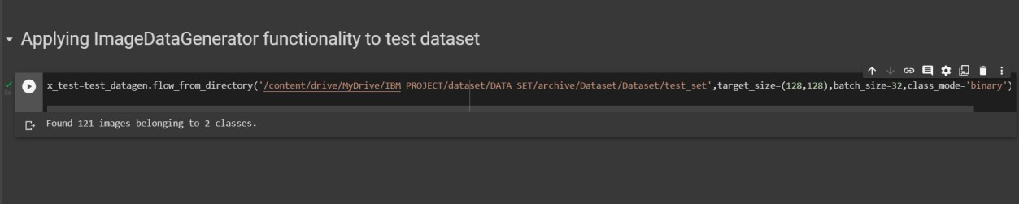

**IMPORTING MODEL BUILDING LIBRARIES:**

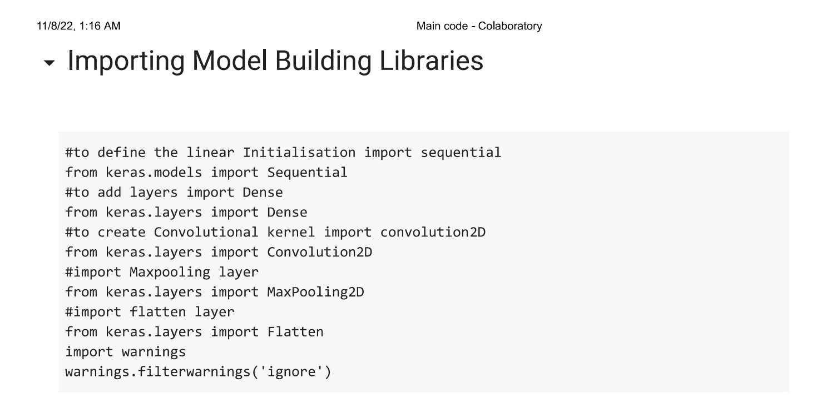

**INITIALIZING THE MODEL:**

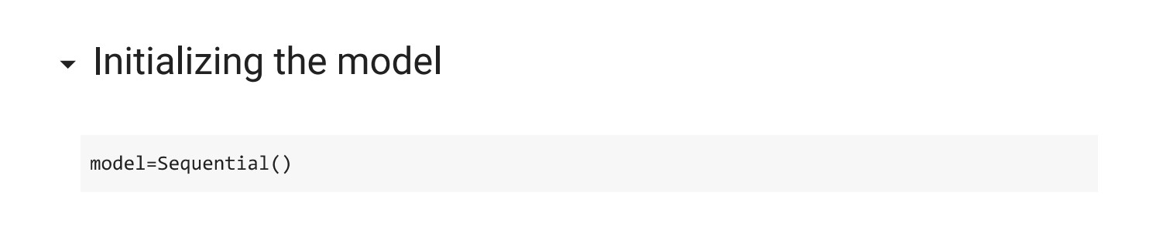

**ADDING CNN LAYERS:**

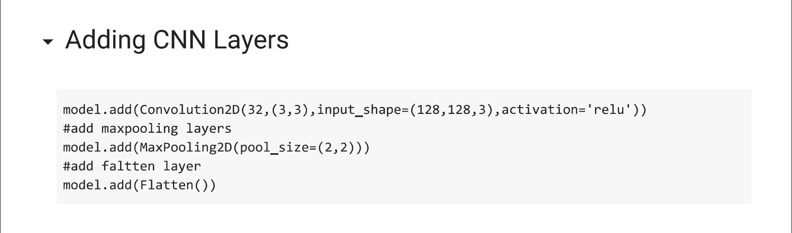

**ADDING DENSE LAYERS:**

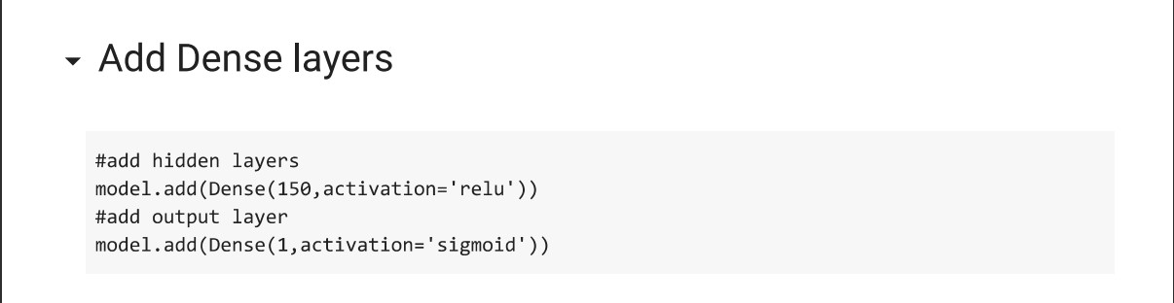

**CONFIGURING THE LEARNING PROCESS:**

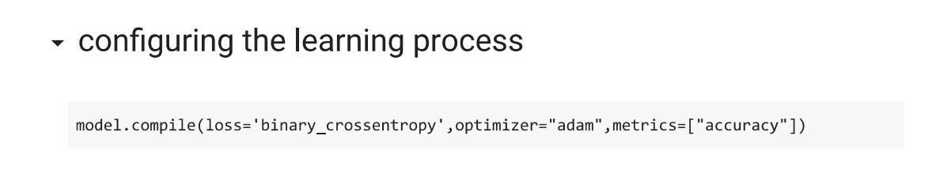

**TRAINING THE MODEL:**

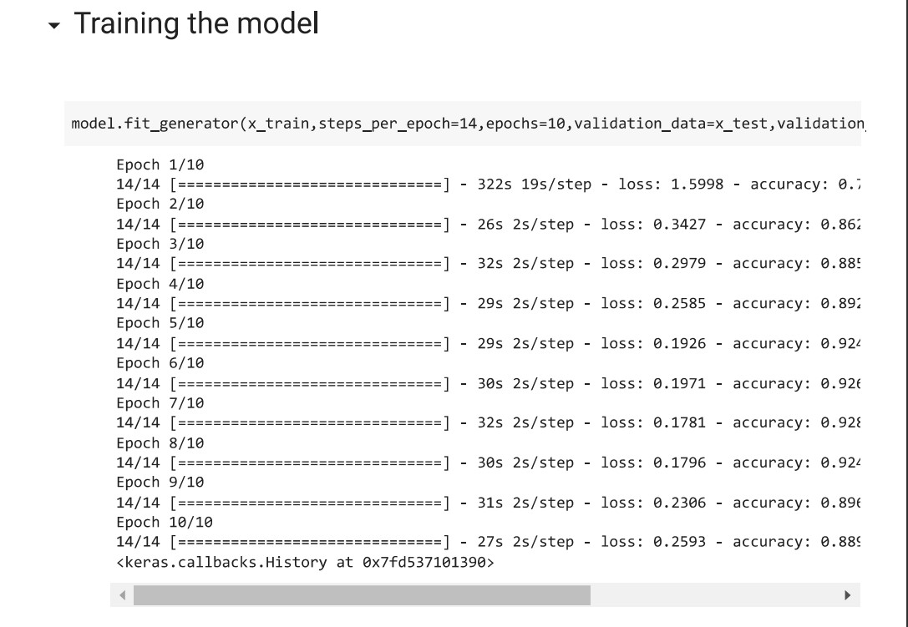

**SAVE THE MODEL:**

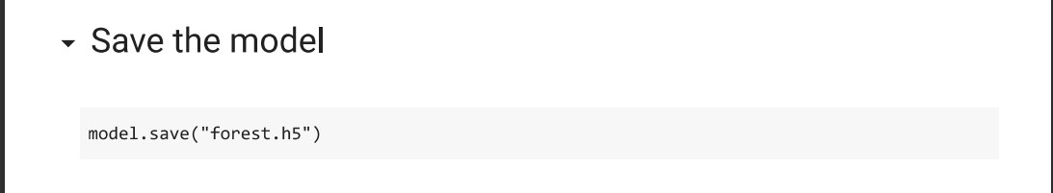

**PREDICTIONS:**

